



**GROUP MEMBER’S**

MUHAMMAD HAMZA

MUHAMMAD ASWAD



# *Certificate of Completion*

TThis is to certify that Website For php care Website has been completed with all functionality by the Students of MISS KIRAN

Submitted to: **Aptech Computer Education**

On

**October 2th, 2023**



# 

# *Acknowledgement*

We were asked to make a user-friendly website on “PHP CARE Website.com”. We earnestly hope that this project will provide all recipe’s required for the user to fulfill their needs. They are easy to use for our tips and methods.

We would like to thank All-Mighty ALLAH who gave us courage to succeed in completing the Second-semester I-Project. Moreover, we would like to thank our Parents and Family Members who appreciated our work and granted the permission to work on this project late at night. We would also like to thank our classmates and colleagues who shared their ideas and comments to make this project look better every time. The software used in development of the project is Adobe Dream Weaver and pictures are edited in Adobe Photoshop where needed

# 

# *Project Synopsis*

The SRS Electrical appliances are the manufacturers of some electrical products like switch gears, fuses, capacitors, resistors, etc…. These products after manufactured they are sent for testing where the product is subjected to some testing conditions, and then after the testing is successful at their laboratories they are sent to CPRI for further testing process, so that they can get it approved from CPRI and then release the product into the market. If the testing fails then the product is sent back for remanufacturing it and then they are again subjected to tests.

# *Problems Statement:*

Problem statement is attached separately in a file “**Lab Automation**”

**Standards plan:**

Every code block must have comments.

The logic of the program needs to be explained. Proper documentation should be maintained.

Complete Project Report along with synopsis, code and documentation should be prepared.

**Documentation:**

No project is complete without documentation. In fact, it is one of the most important activities during the development of a project. The documentation of an ideal project will be in the form of a project report comprising of the following documents:

* Certificate of Completion.
* Table of Contents.
* Problem Definition.
* Customer Requirement Specification.
* Project Plan.
* E-R Diagrams.
* Algorithms.
* GUI Standards Document.
* Interface Design Document.
* Task Sheet.
* Project Review and Monitoring Report.



# ***Hardware and Software Requirements***

**Hardware**

* A minimum computer system that will help you access all the tools in the courses is a Pentium 166 or better
* 128 Megabytes of RAM or better

**Operating System**

* LINUX / Windows 2000 Server (or higher if possible)

**Software**

* PHP
* MySQL
* PERL
* Apache



# ***REQUIREMENT SPECIFICATION***

**INTRODUCTION:**

The thirst for learning, upgrading technical skills and applying the concepts in real life environment at a fast pace is what the industry demands from IT professionals today. However busy work schedules, far-flung locations, unavailability of convenient time-slots pose as major barriers when it comes to applying the concepts into realism. And hence the need to look out for alternative means of implementation in the form of laddered approach.

The above truly pose as constraints especially for our students too! With their busy schedules, it is indeed difficult for our students to keep up with the genuine and constant need for integrated application which can be seen live especially so in the field of IT education where technology can change on the spur of a moment. *Well, technology does come to our rescue at such times!!*

Keeping the above in mind and in tune with our constant endeavour to use Technology in our training model, we at Aptech have thought of revolutionizing the way our students learn and implement the concepts using tools themselves by providing a *live and synchronous e project learning environme*nt!

# ***Architecture And Design of The System***

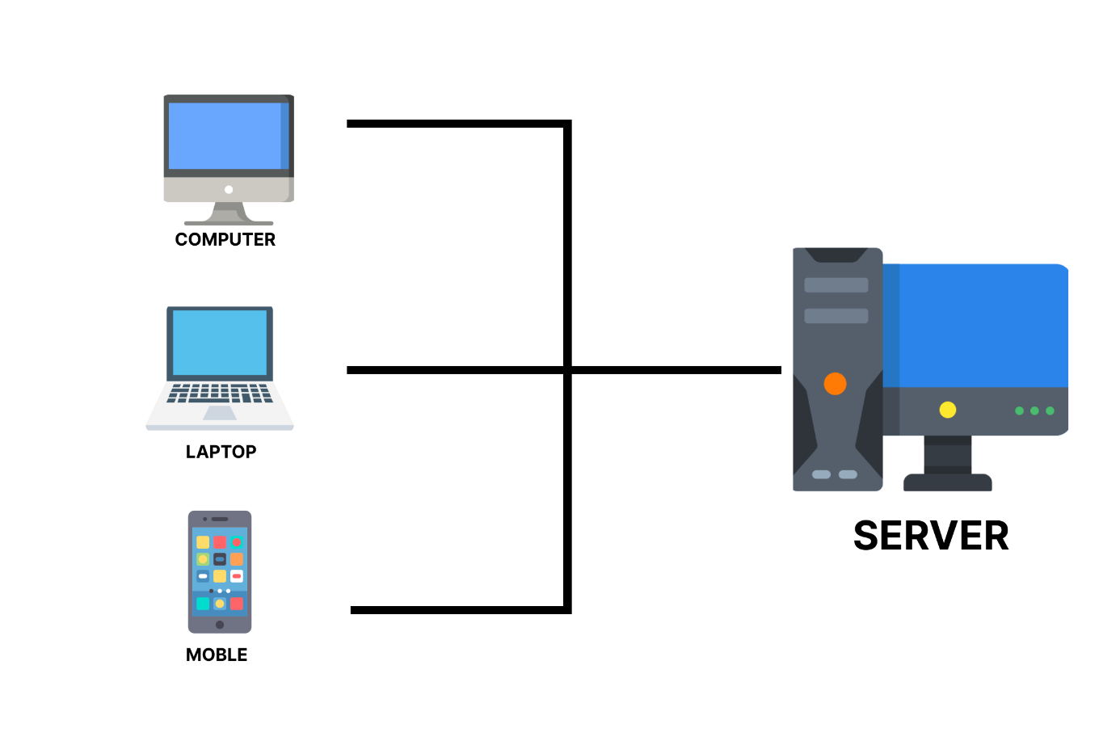

**BackEnd Technologies**

* Html 5
* CSS
* Apache
* Bootstrap
* Php
* MySql

# ***ENTITY RELATION DIAGRAM***

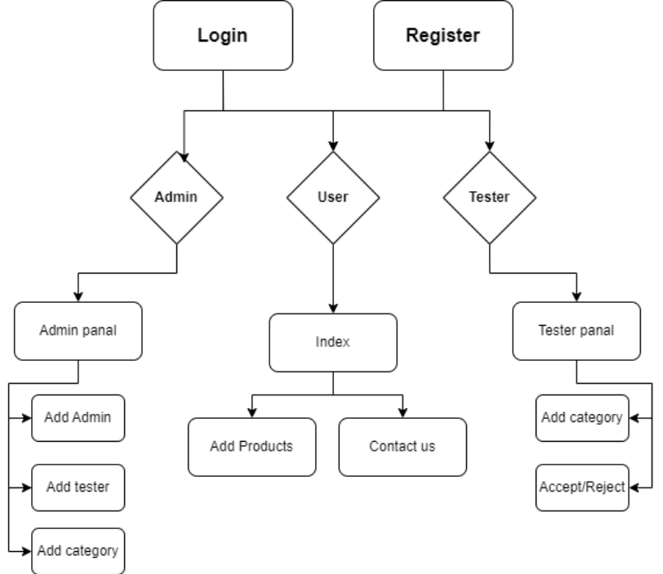

# ***DATABASE STRUCTURE***

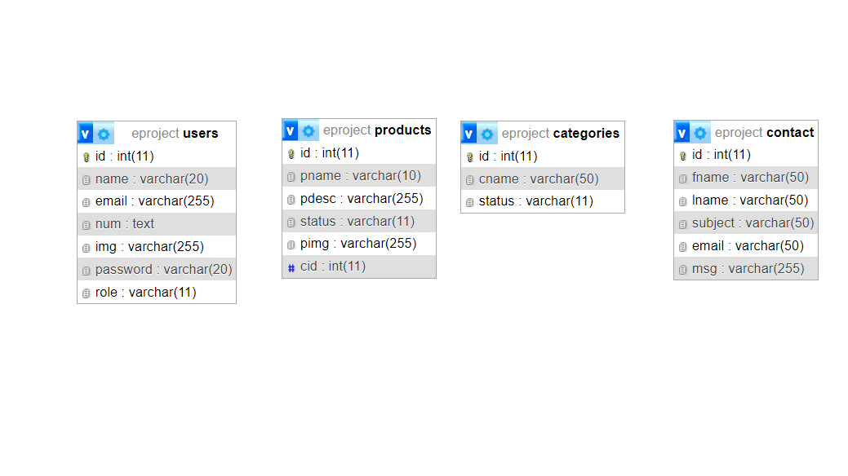

# ***PICTURES OF ADMIN PANEL***

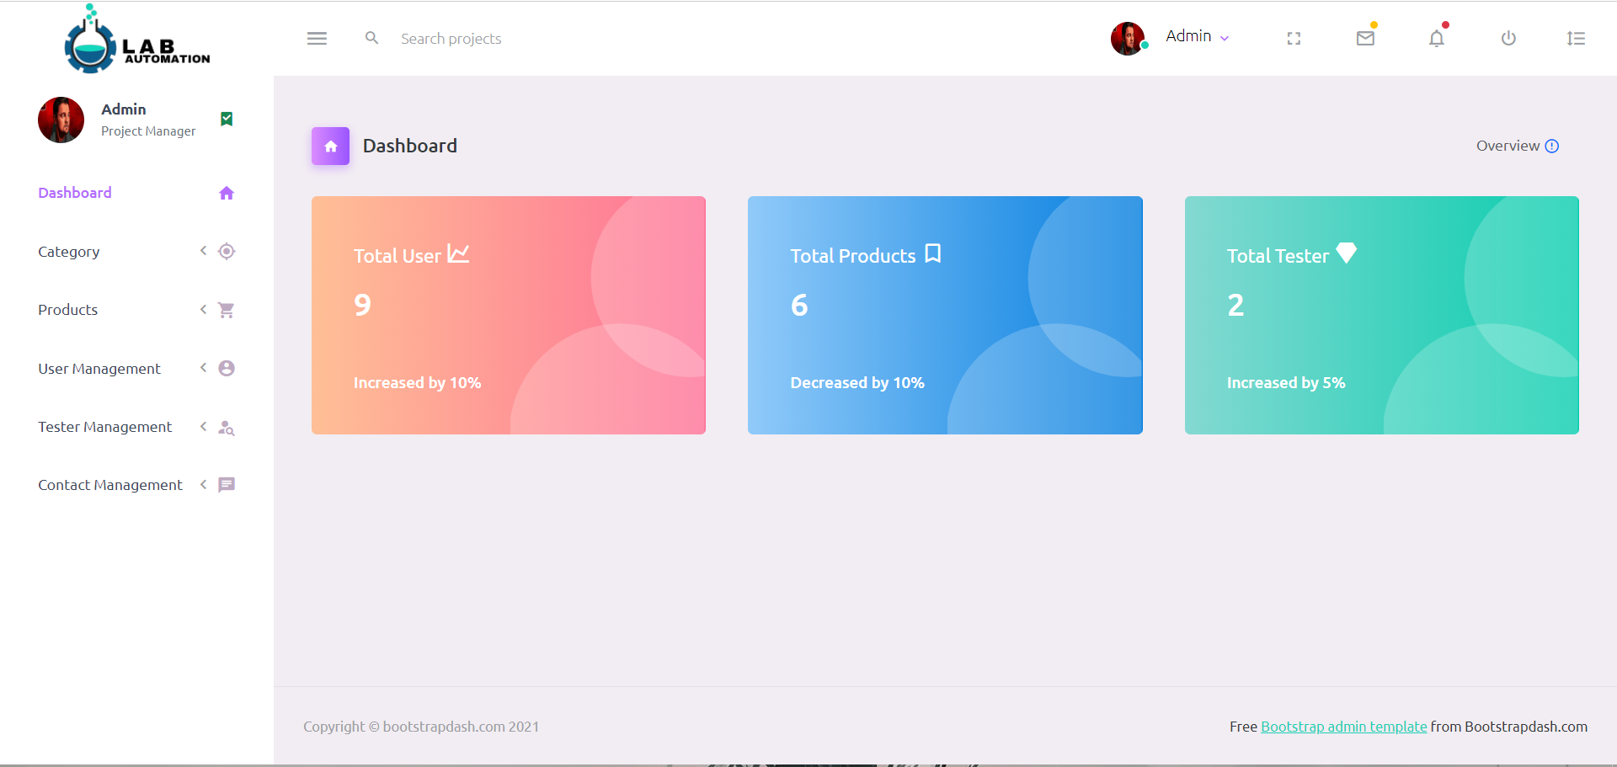

# ***PICTURES OF TESTER PANEL***

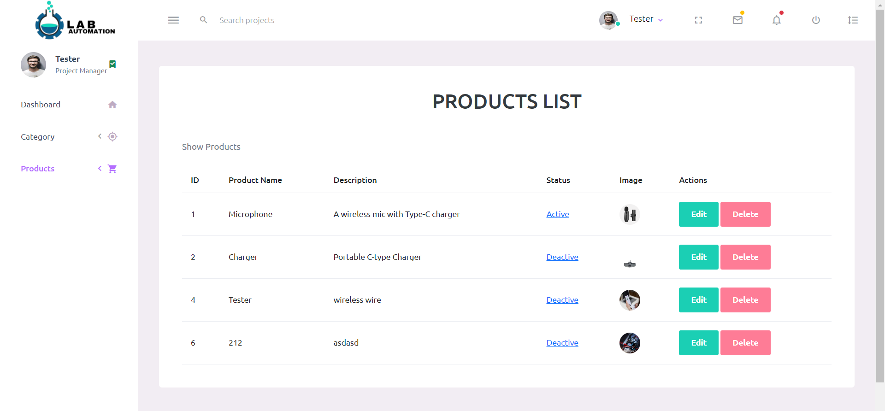

# ***PICTURES OF WEBSITE INDEX***

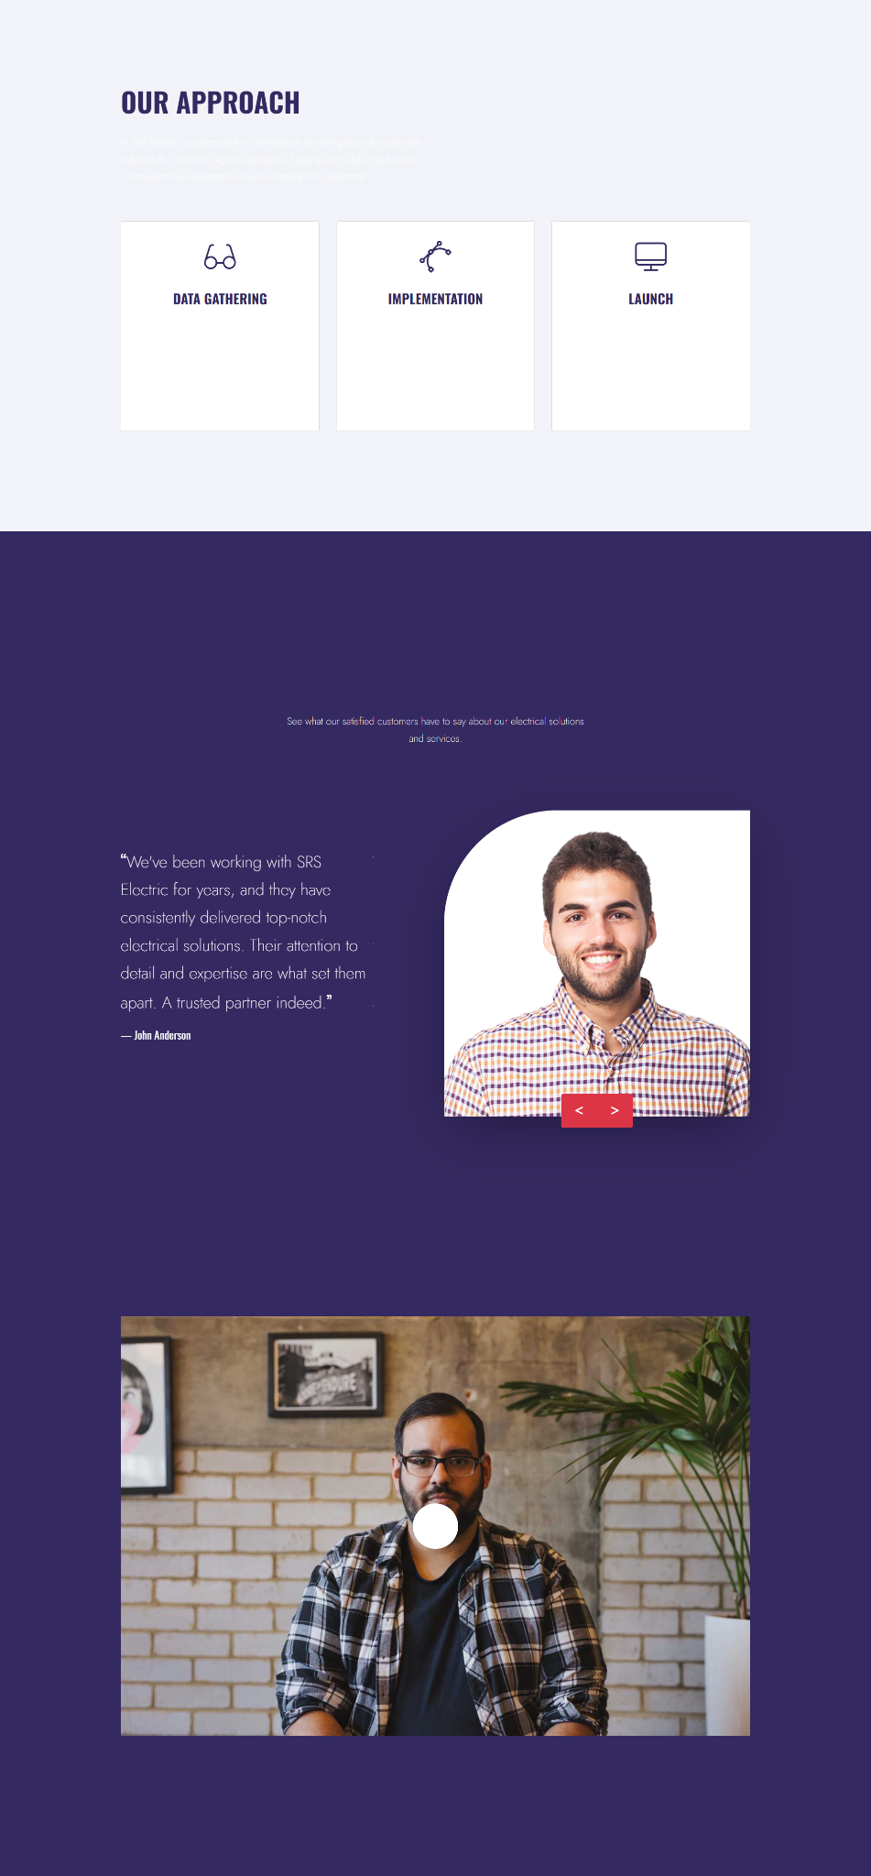

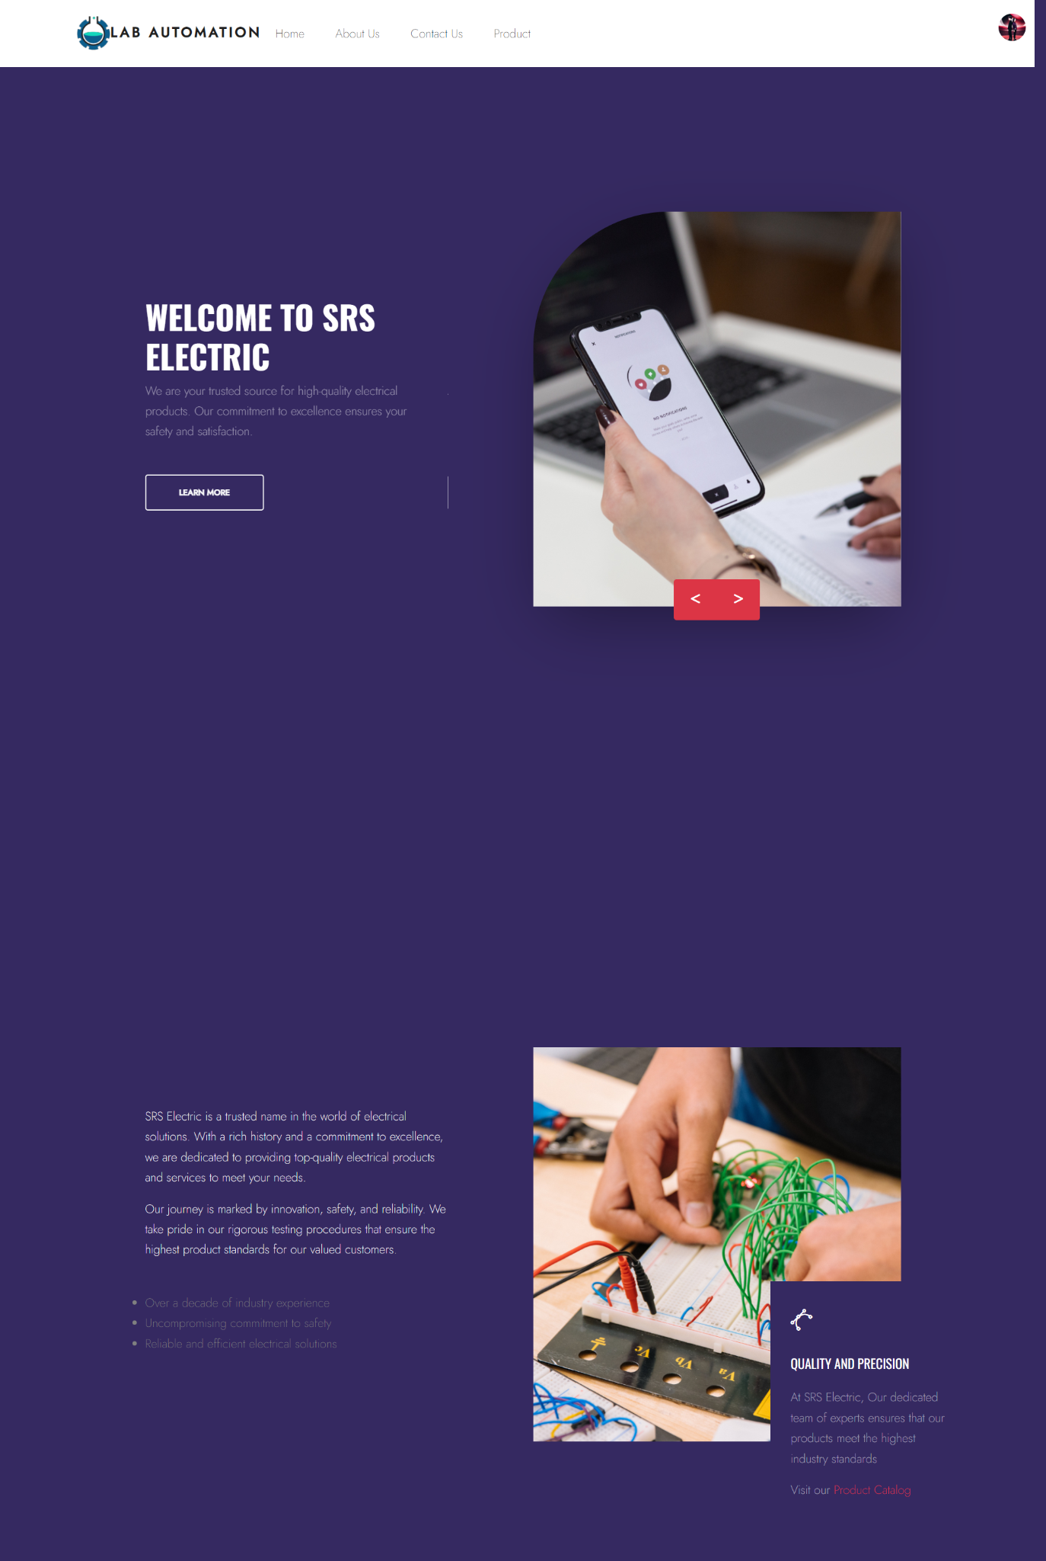

\\

# ***CONTACT US***

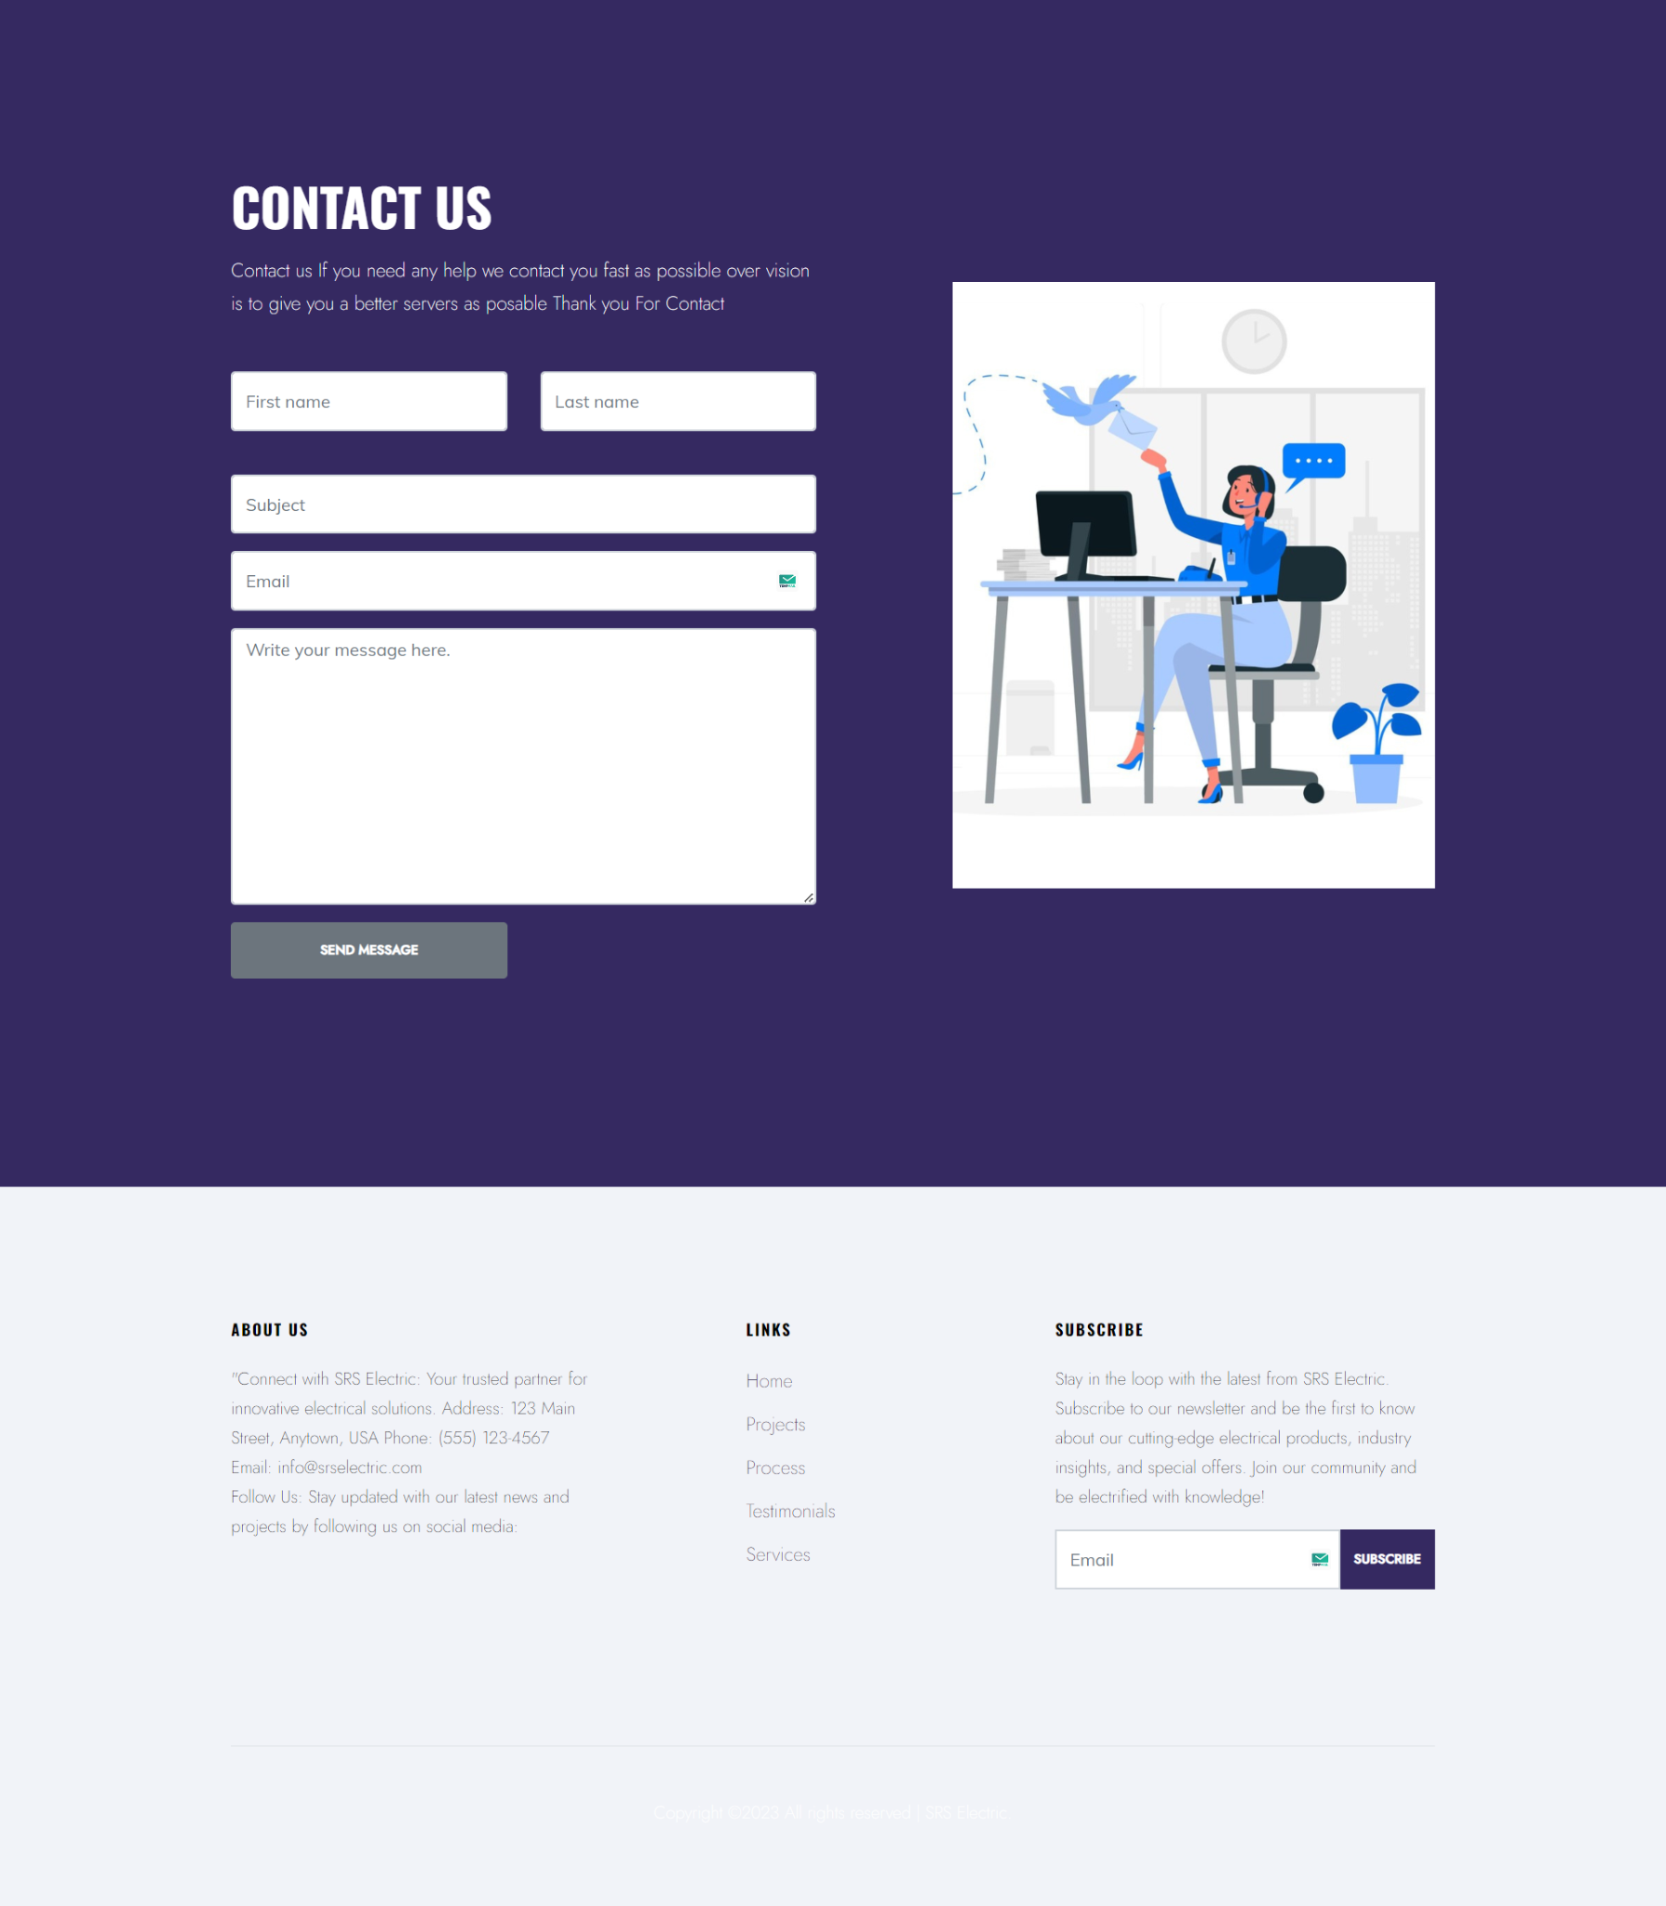

# 

# 

# 

# ***ADD PRODUCTS***

# 

# 

# 



***Task Sheet***

| **Project Ref. No:** | | **Project Title:** | **Data of Preparation of Activity Plan** | | | |
| --- | --- | --- | --- | --- | --- | --- |
|  |
|  |
| Sr. No. | Task | Actual Start Data | Actual Days | Team Mate Name | Status |  |
|  |
| 1 | Analysis | LAB AUTOMATION | 2-10-2023 | 2 | Aswaad,Hamza | ok |  |
| 2 | Design |  | 25 | Aswad,Hamza | ok |  |
| 3 | Responsive |  | 15 | Aswad,Hamza | ok |  |
| 4 | Development |  | 25 | Aswad, Hamza | ok |  |
| 5 | Data Collecting |  | 3 | Hamza,Aswad | ok |  |
| 6 | Testing |  | 1 | Hamza,Aswad | ok |  |
| 7 | Documentation |  | 1 | Hamza.Aswad | ok |  |
|  |  |  |  |  |  |  |
|  |  |  |  |  |  |  |
|  |  |  |  |  |  |  |
|  |  |  |  |  |  |  |
|  |  |  |  |  |  |  |
|  |  |  |  |  |  |  |
|  |  |  |  |  |  |  |
|  |  |  |  |  |  |  |
|  |  |  |  |  |  |  |